**ניהול פרויקט תוכנה – עבודת 3:**

**מגישים:**  
ליאור וקנין  
פבל שוורצוב  
מורדי דבח

In the development of the features we worked in TDD methodology. We wrote the unittests for our feature before we implemented them. And then we implemented the features in the process of refactoring the code.

First feature – Mail Domain Location Finder:

In this feature we ask the user for a (valid) email address. The feature then finds the domain of the email and find it’s IP address (using socket library).

Then the feature uses the API for finding the location of an IP address.

Link to the API: <https://ipapi.co/developers>

Finally, in case of success, the feature returns the email domain location. Otherwise, an error will show for the user.

Second feature – Mail Validator:

This feature check if a given email address is either valid or not.

This feature asks the user for an email address and return True in case of a valid email address and false otherwise.  
(The validation of the email address is checked by a regular expression).

In addition, Using an API the feature checks if the email domain is valid. That is, if the email domain exists.

Link to the API: <https://domainsdb.info>

If the email address is valid and its domain name exists (using the API) then the feature will return true (“Valid”). Otherwise, False (“Invalid”).

Tests passing on the local system:

For feature one:

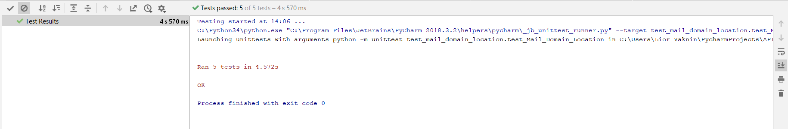

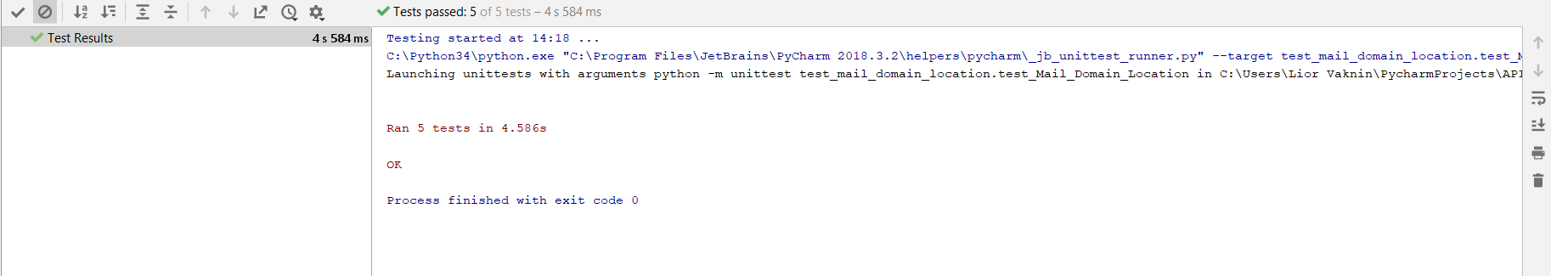For feature two:

For all the units (Ten unittests):

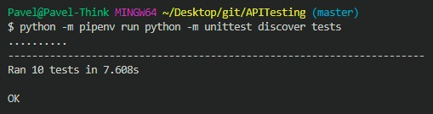

The CICD pipeline

Build:  
Running all tests for each unit.

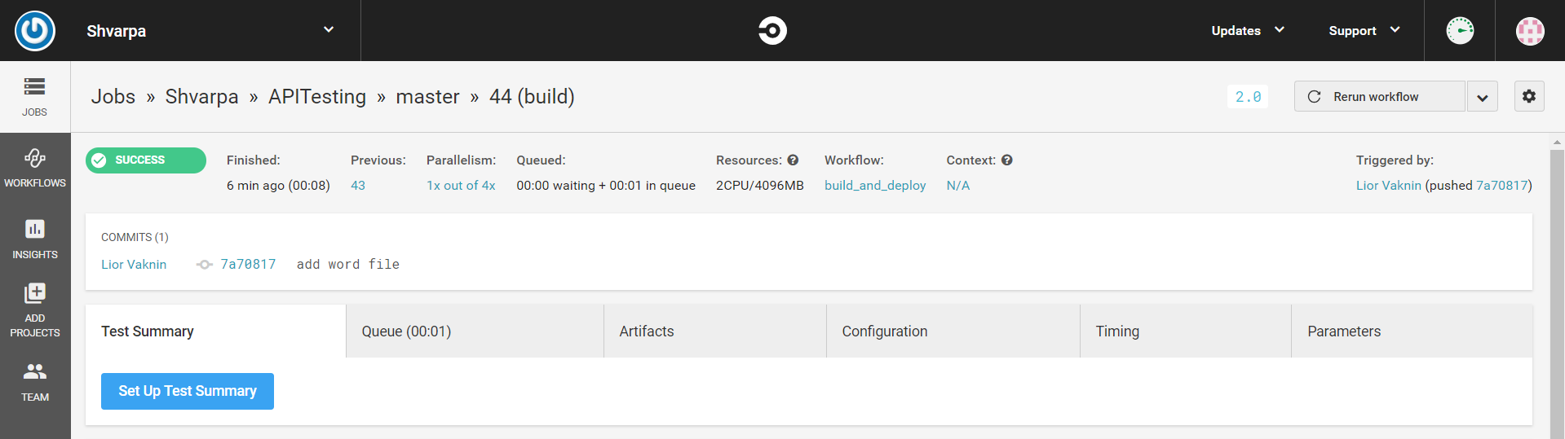

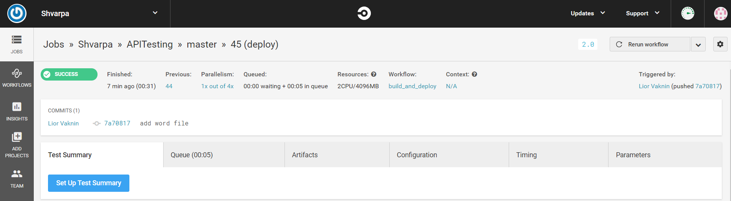Deploy:  
For the README.md file to HeroKu.

A link to the services used:

Link to the GitHub project: https://github.com/Shvarpa/APITesting

Link to the first API: <https://ipapi.co/developers>

Link to the second API: <https://domainsdb.info>